**HOME PAGE**

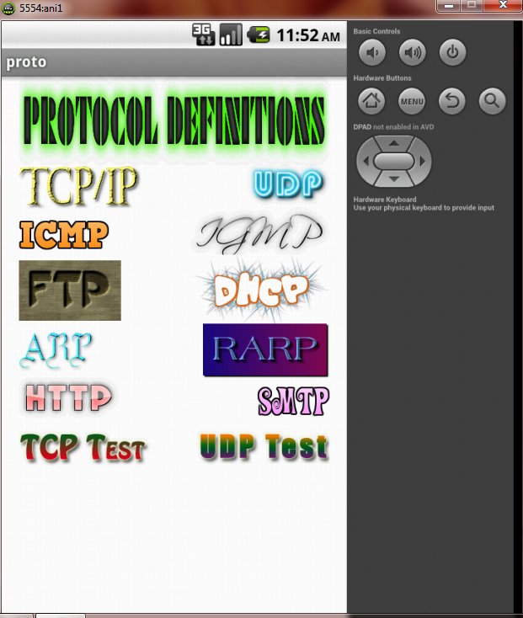

**TRANSMISSION CONTROL PROTOCOL (TCP):**

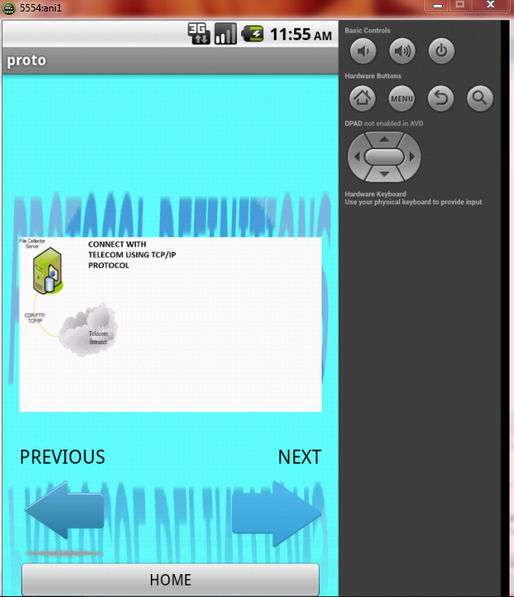

**TCP connection with Switch1**

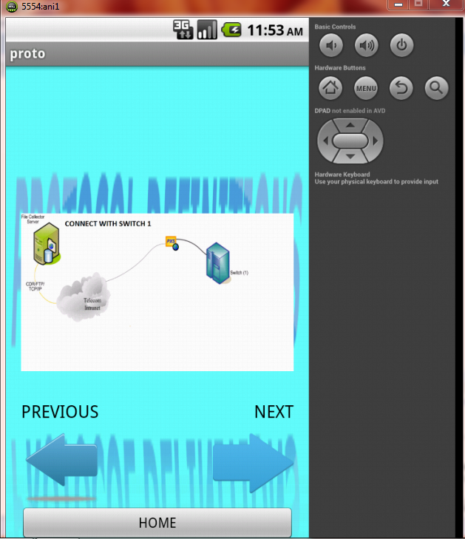

**TCP connection with Switch2**

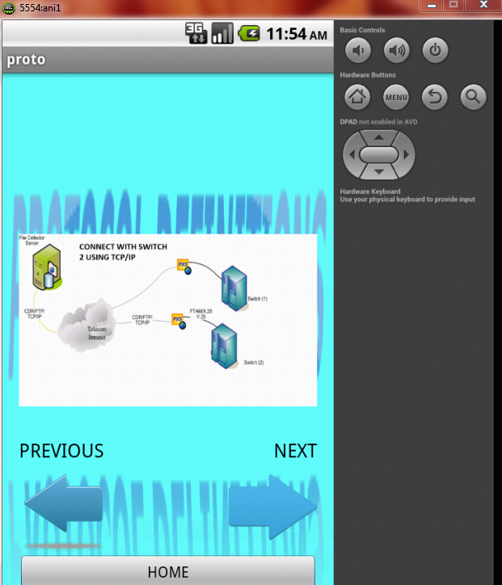

**TCP connection with Switch3**

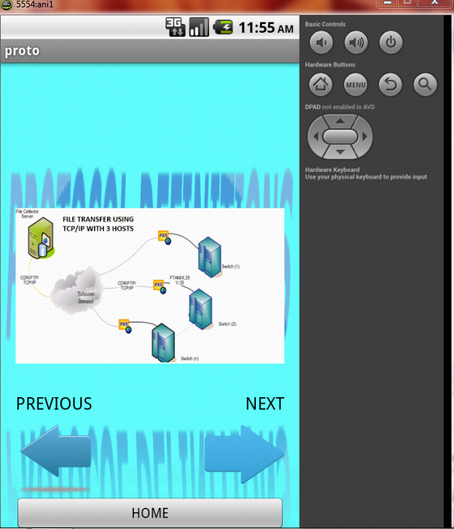

**USER DATAGRAM PROTOCOL (UDP):**

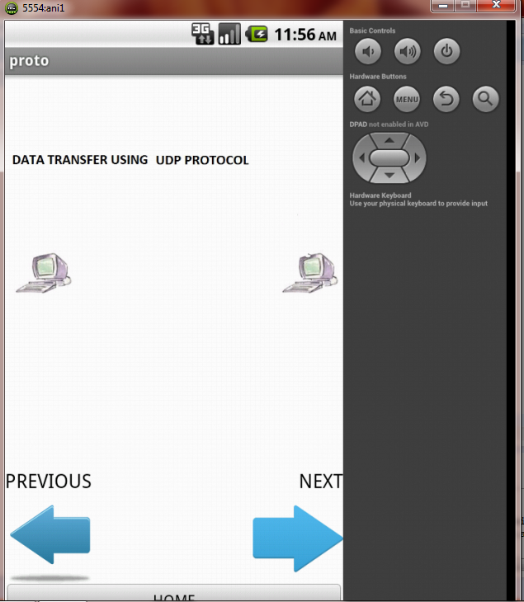

**Establishing connection in UDP**

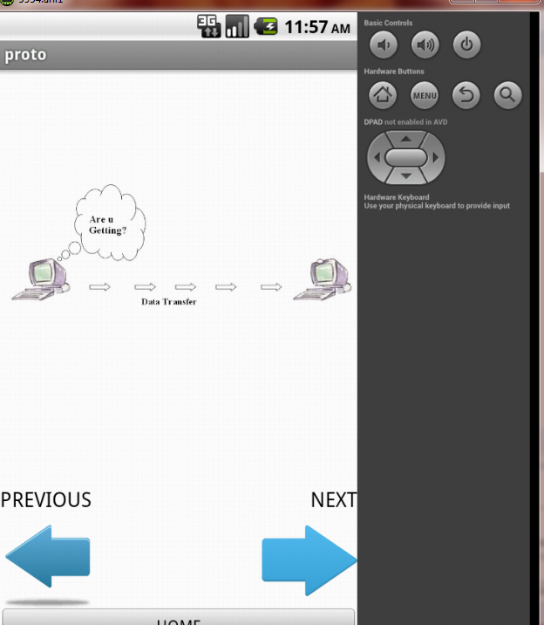

**Connection between server and client in UDP**

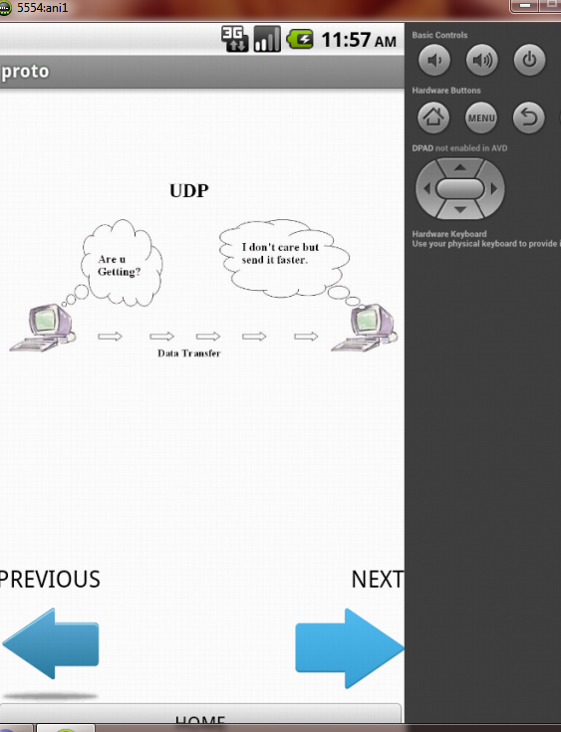

**Acknowledgement in UDP**

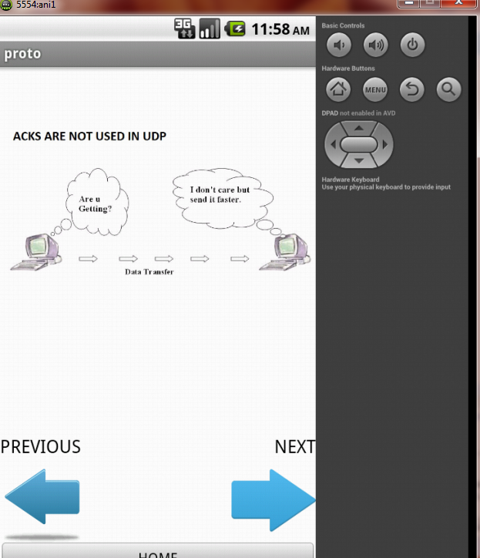

**INTERNET CONTROL MESSAGE PROTOCOL (ICMP):**

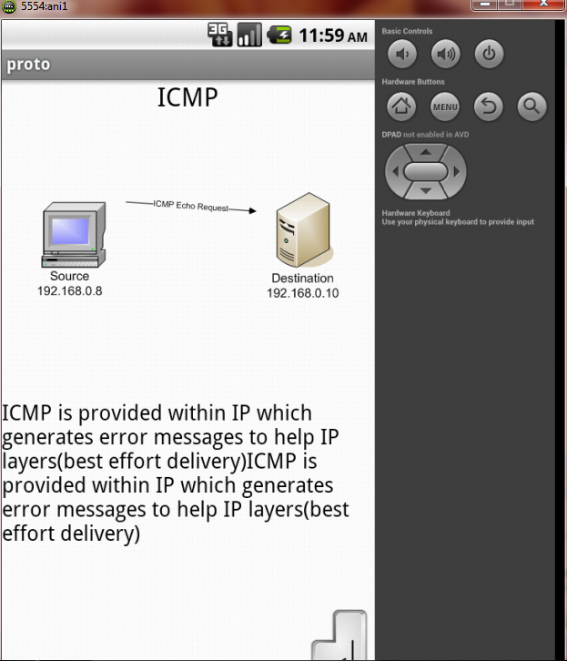

**ICMP connection with router1**

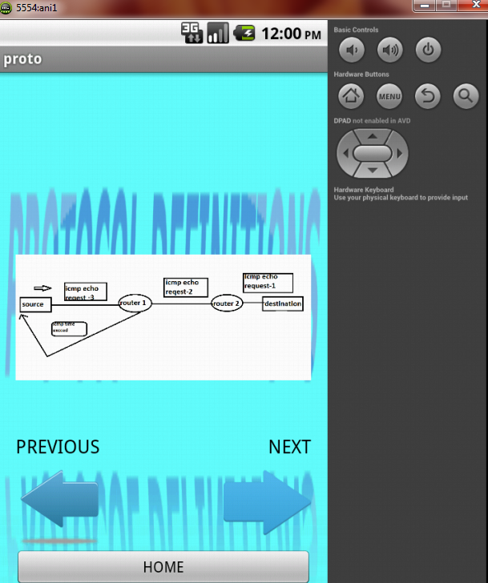

**ICMP connection with router2**

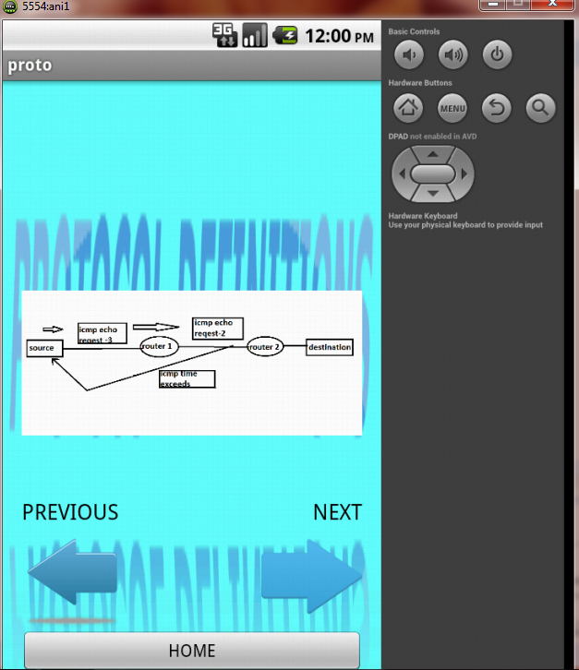

**ICMP connection between source and destination**

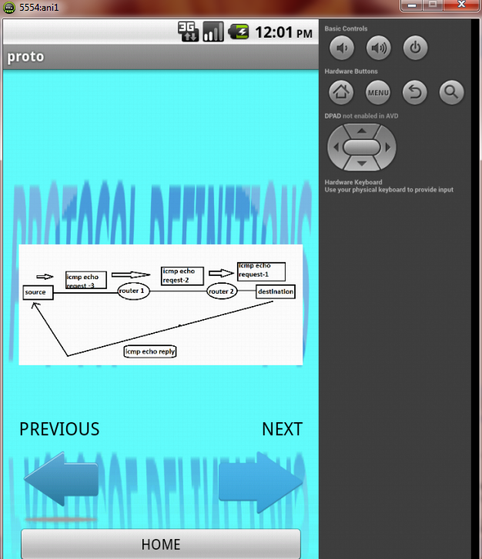

**INTERNET GROUP MANAGEMENT PROTOCOL (IGMP):**

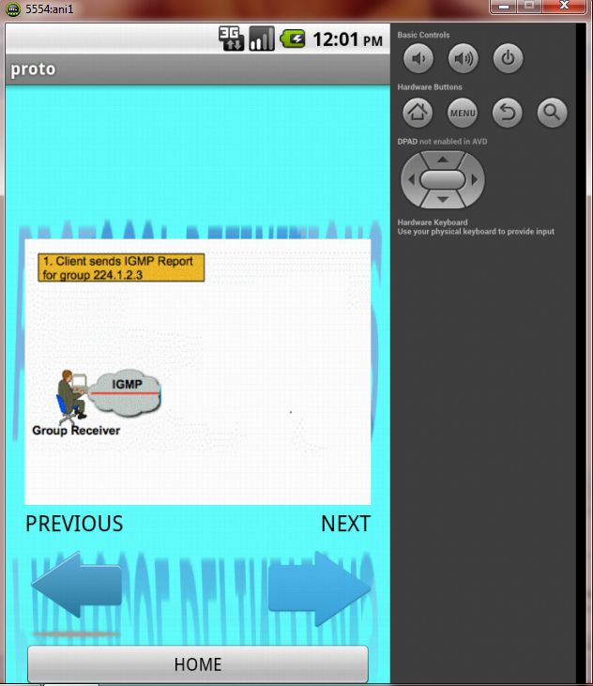

**IGMP Connection with router**

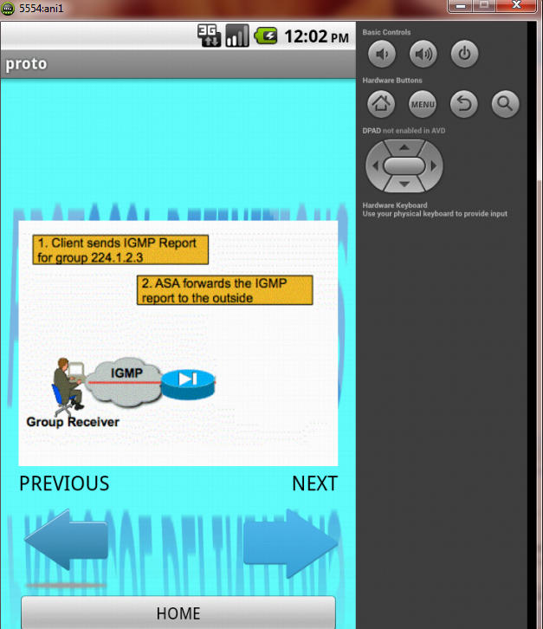

**IGMP connection between sender and receiver**

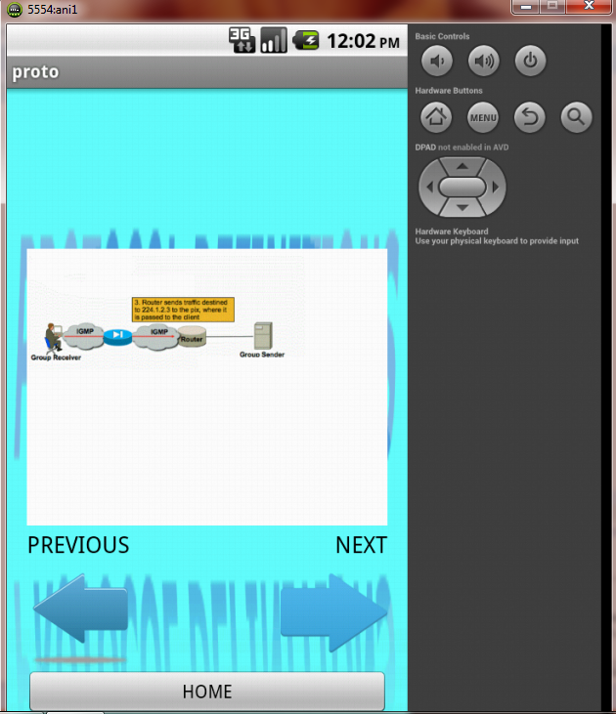

**IP configuration in IGMP**

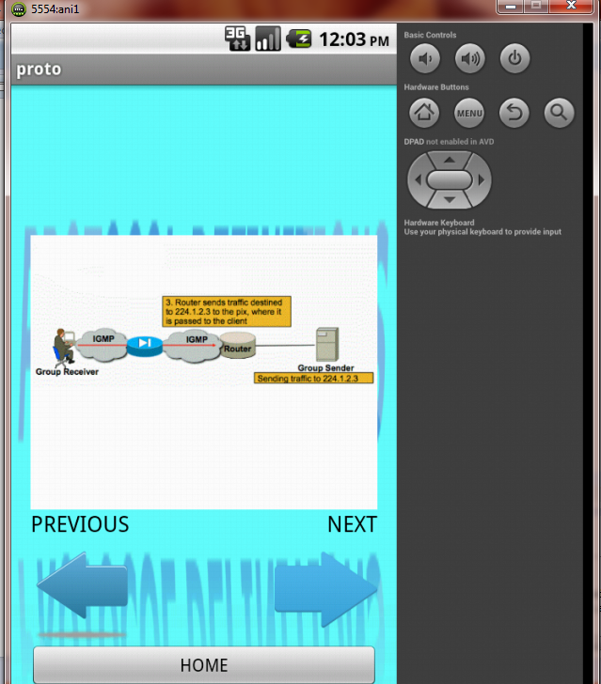

**ADDRESS RESOLUTION PROTOCOL (ARP):**

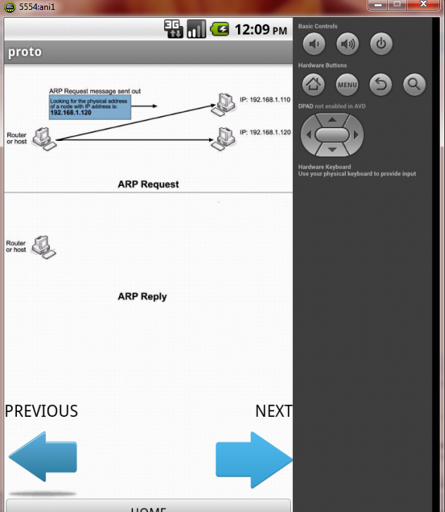

**ARP request with 3 systems**

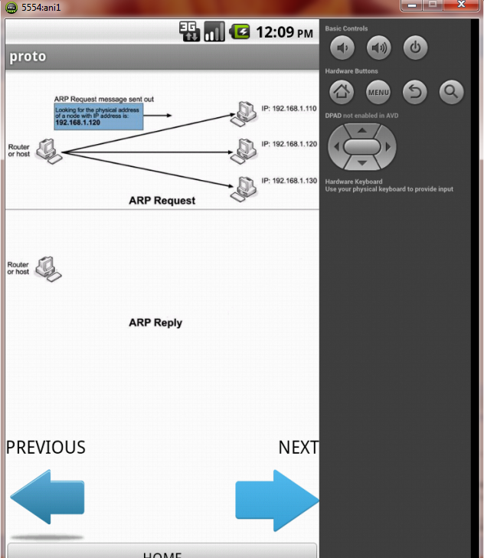

**Establishing ARP reply**

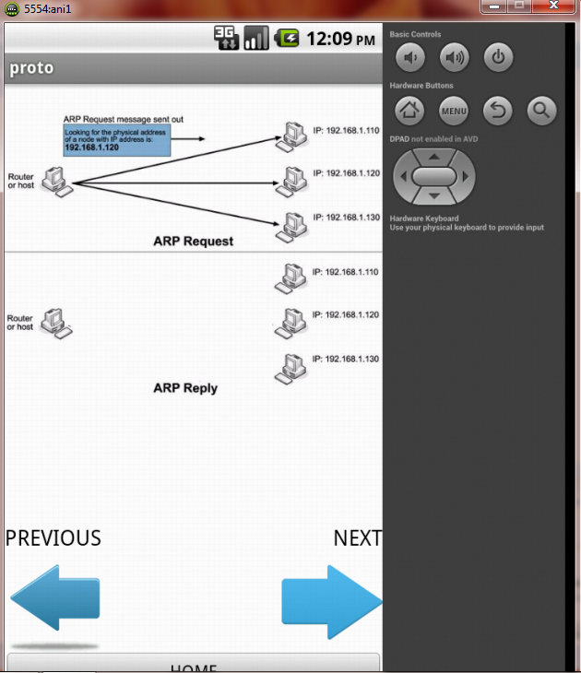

**ARP reply between sender and receiver**

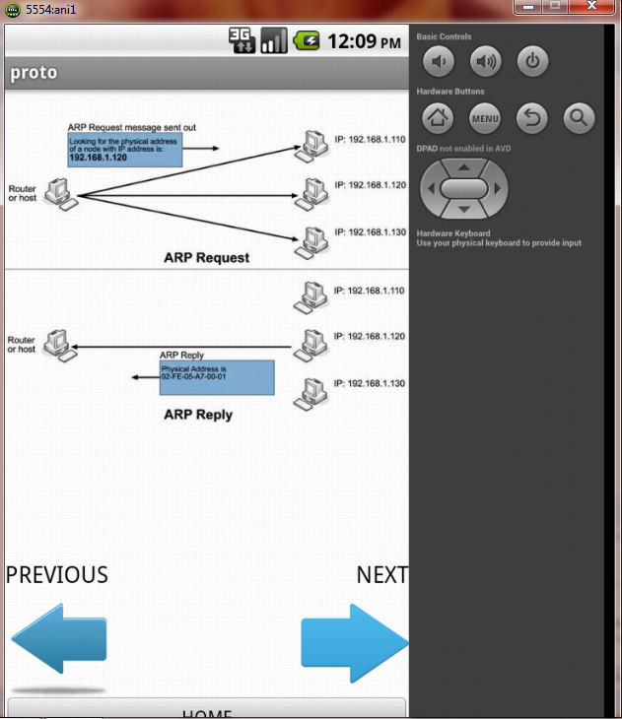

**REVERSE ADDRESS RESOLUTION PROTOCOL (RARP):**

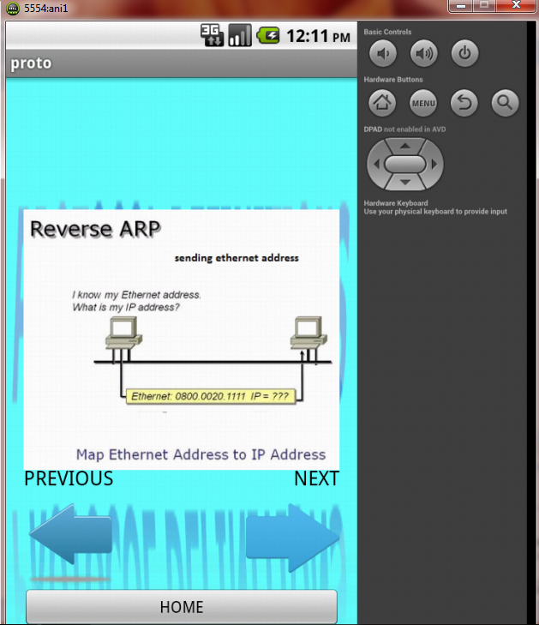

**HYPERTEXT TRANSFER PROTOCOL (HTTP):**

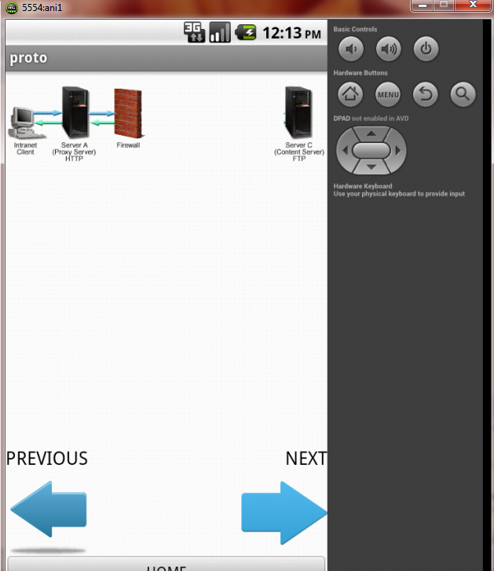

**Connection through firewall in HTTP**

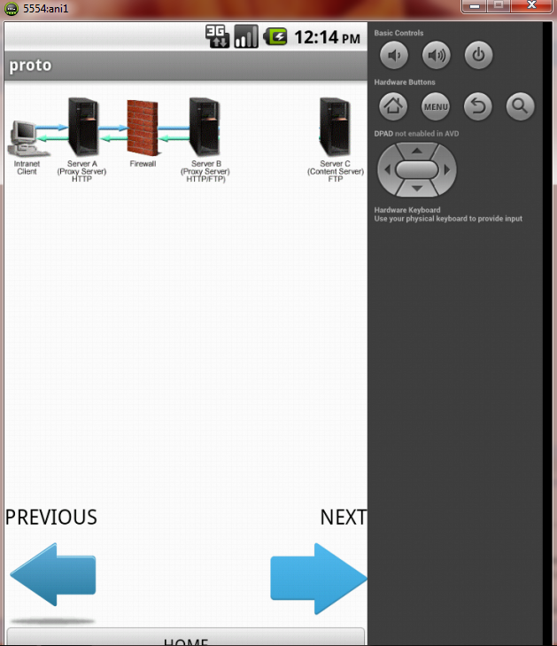

**Internet connection in HTTP**

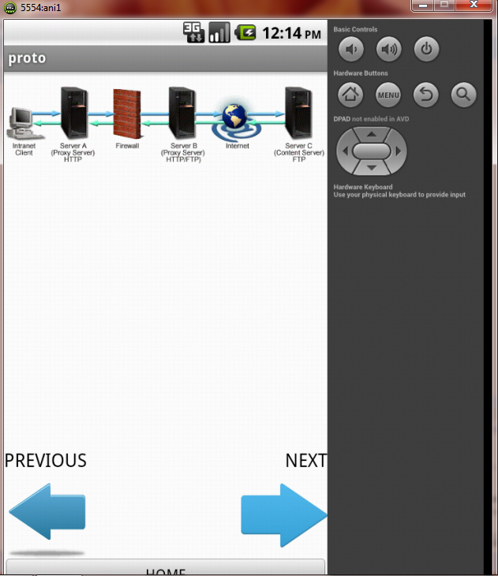

**FILE TRANSFER PROTOCOL (FTP):**

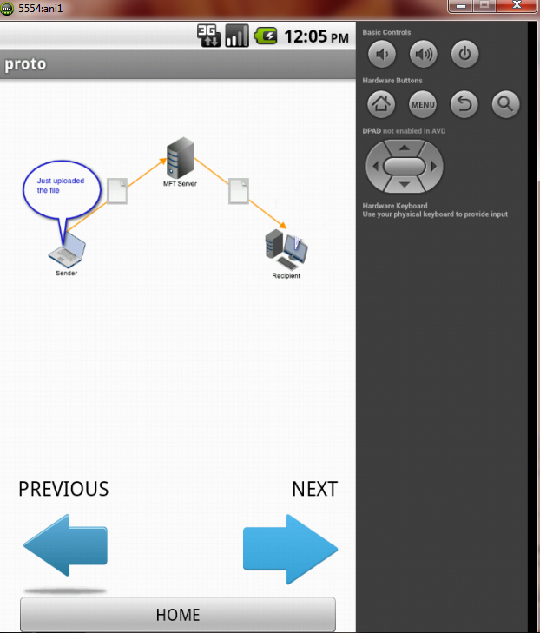

**DYNAMIC HOST CONFIGURATION PROTOCOL (DHCP):**

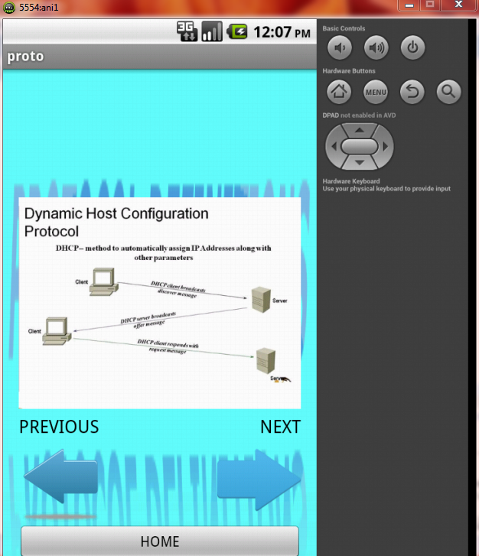

**SIMPLE MAIL TRANSFER PROTOCOL (SMTP):**

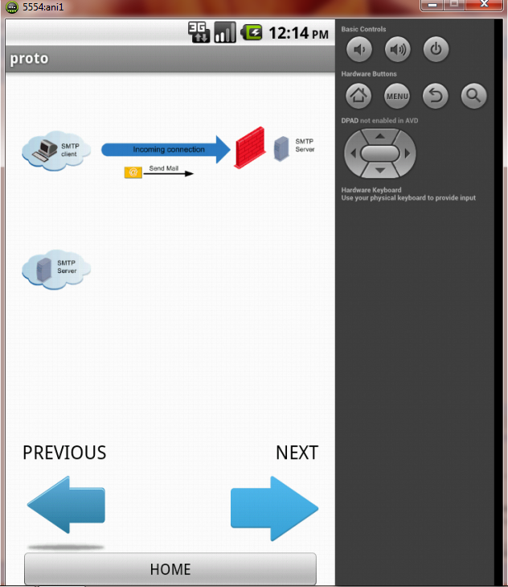

**Scanning of incoming mails in SMTP**

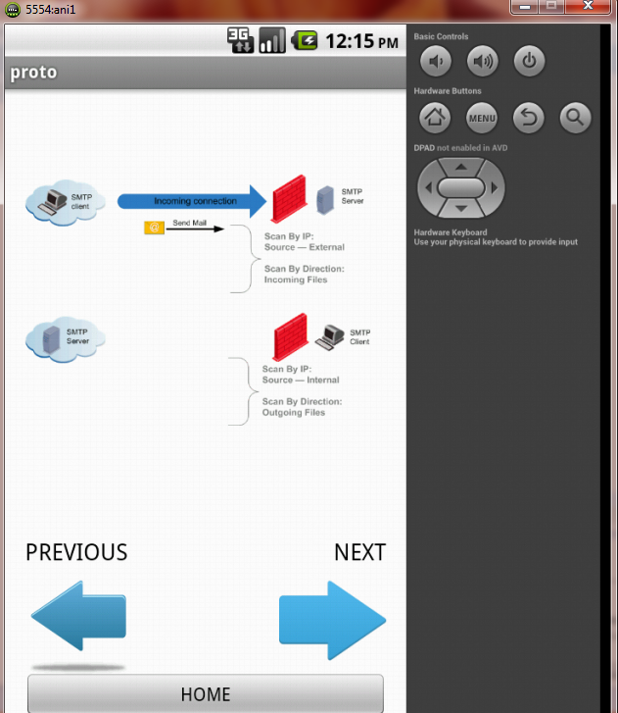

**Scanning of outgoing mails in SMTP**

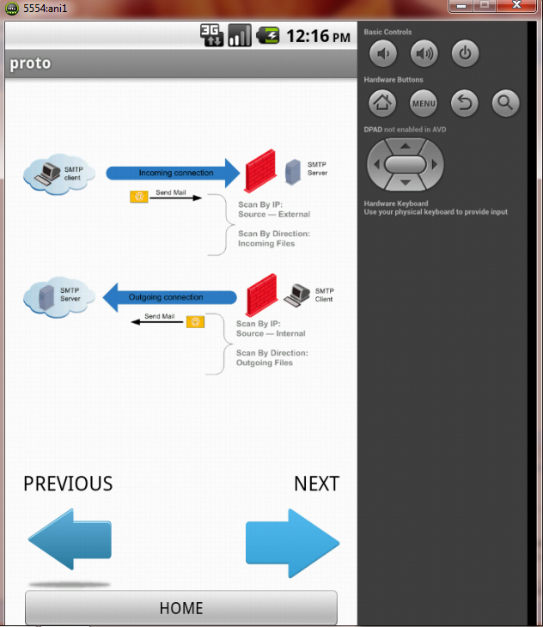

**TCP AND UDP TEST:**

